REGISTRATION & SETTING UP THE DIRECT DEBIT ON JOININ

This document gives you some background information about JoinIn and lays out the steps you need to take to get registered. It just take a few minutes.

BACKGROUND INFORMATION
It is important to understand how JoinIn works and what it does. This will help you understand the registration process.

JoinIn is a management system for sports clubs. It is in use by many clubs and some of you will have already come across it.

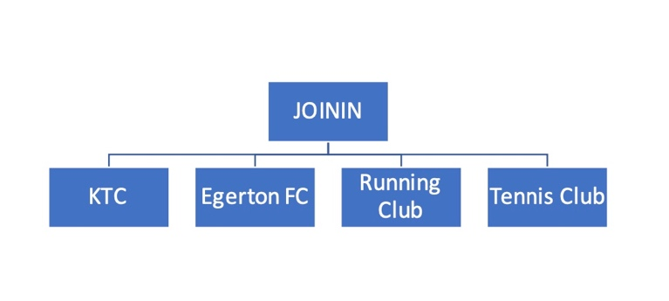
JoinIn allows clubs to create their own custom site within the JoinIn framework. Lots of clubs across the country use JoinIn to manage members details, emergency contacts, medical stuff, and consents. The system also allows members to book and pay for membership and sessions. There are loads of other things it can do but we’re keeping it simple to start with.

What this means in terms of registration is that you first of all register with JoinIn and then you register with Knutsford Tri Club. It is a two stage process. Some of you already have an account with JoinIn so in this case you just need to register for Knutsford Tri Club.

Please note that registration is not complete until you have entered your emergency contacts, medical info and agreed to the consents.

REGISTRATION
Please click on the link below to start registration

Click here to register for JoinIn

or

https://app.joinin.online/#/app/joinin/organisation/shop/621c3f36-7307-4186-bc80-5a04983ca275

This starts the registration process. Click on the box “Monthly Adult membership” and basically follow the instructions.

After clicking on “add to basket”, click on the basket icon in the top right hand corner and you will then be asked to sign in.

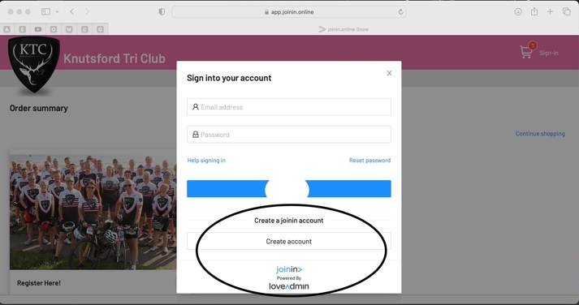
If you already have a JoinIn account just go ahead and “Sign into your account”. If you don’t have a JoinIn account you need to create one. Follow the steps at the bottom of the screen to “Create a JoinIn account”.

Having created a JoinIn account you will be asked to verify by email. Having done this, return to your Knutsford Tri Club account.

Having signed in to your KTC JoinIn account, you will then be taken back to the Knutsford Tri Club Home page. Click on the “Monthly Adult membership” tab and then “proceed to checkout”. The checkout process involves agreeing to various consents and setting up the Direct Debit mandate.

FAQ – USEFUL INFORMATION

- You can register on a desktop, on your phone or iPad. It’s the same process but a bit more squashed on the phone.

- There is no app for JoinIn yet but it works really well on the phone for session booking etc. Once you’re registered it’s worth setting the web page up on your home screen for easy access. Face ID means it’s easy to log on.

- In JoinIn, the different clubs are called “stores” – so if you’re in the main JoinIn system and are looking for Knutsford Tri Club, go to the menu and look for Knutsford Tri Club in “Stores”. Click on Knutsford Tri Club and you will be taken to the KTC page.

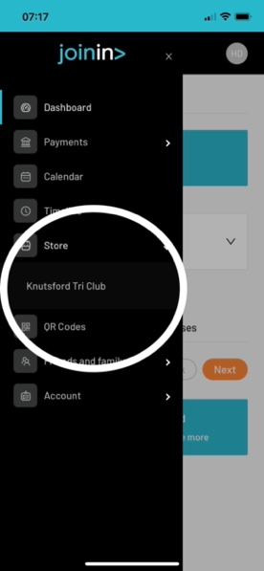

That’s it Registration complete.

